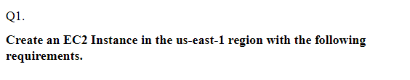

OUTPUT(SCREENSHOTS)

Step-1:



Creating linux instance with the given name “ec2usecase1”

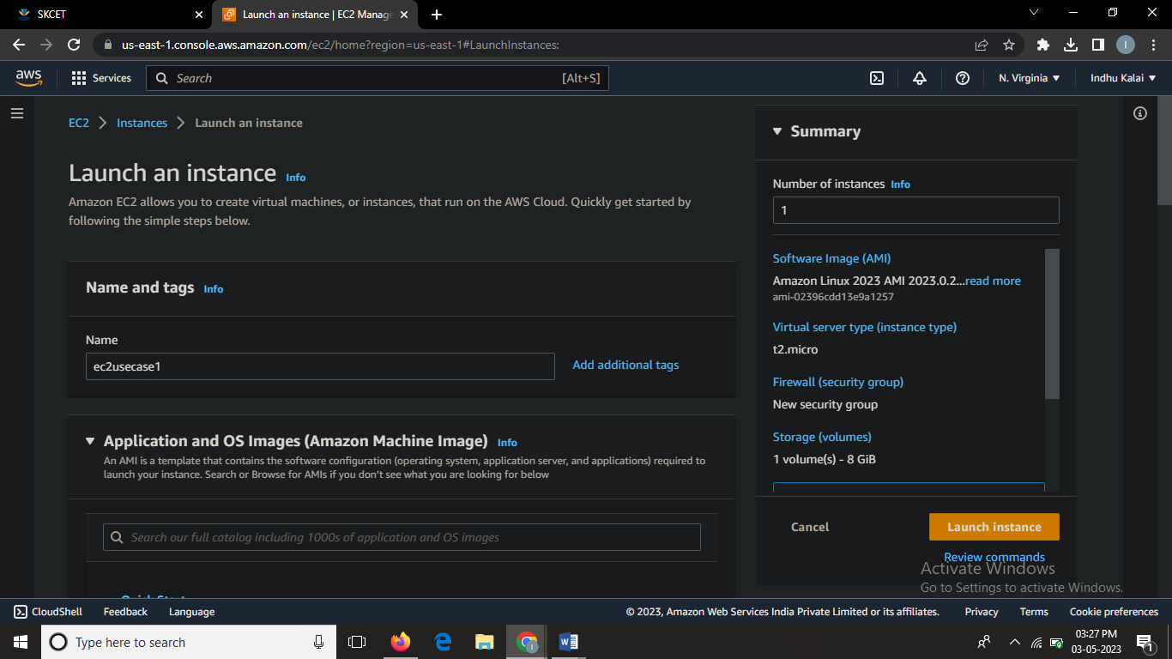



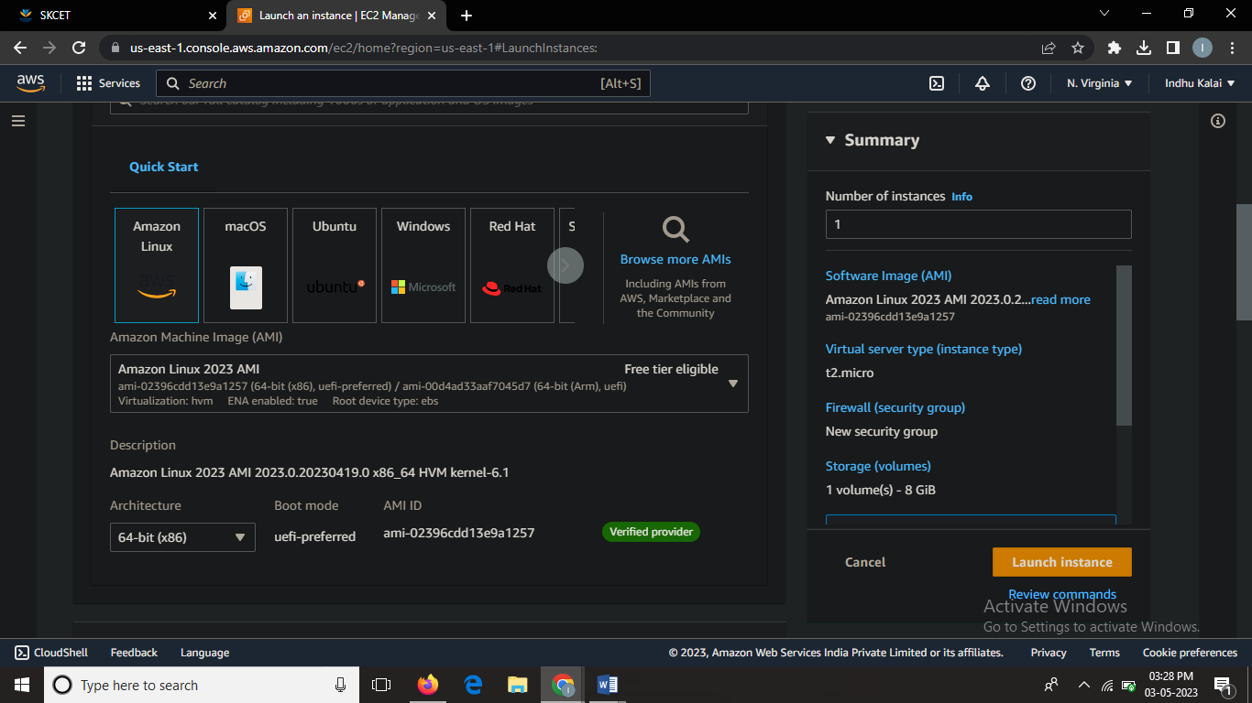

Given keypair name “ec2usecase1”

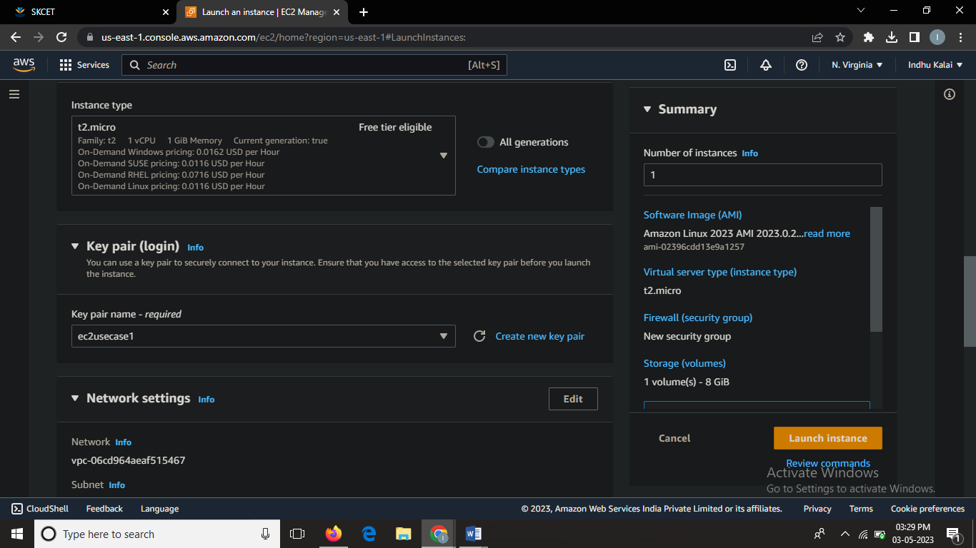

Step2:





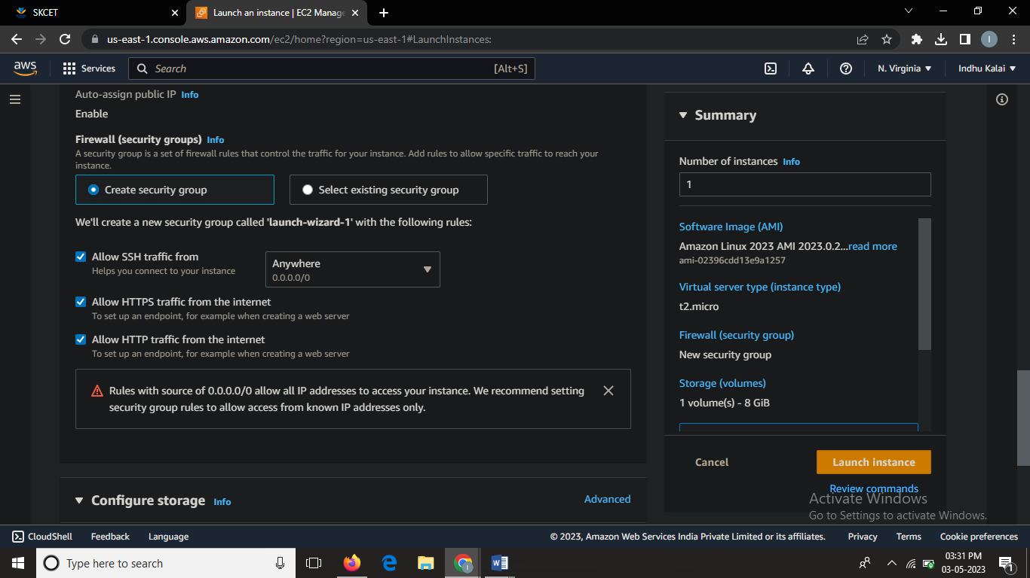

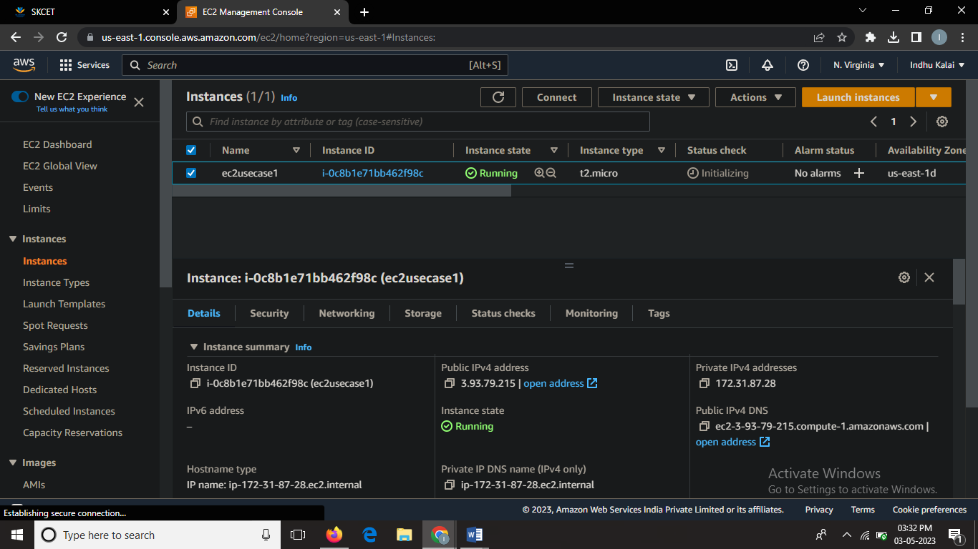

Thus the ec2 instance named “ec2usecase1” has been created successfully.

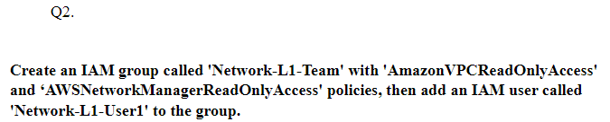

OUTPUT(SCREENSHOTS):

Step1:

Creating group named”Network-L1-Team”:

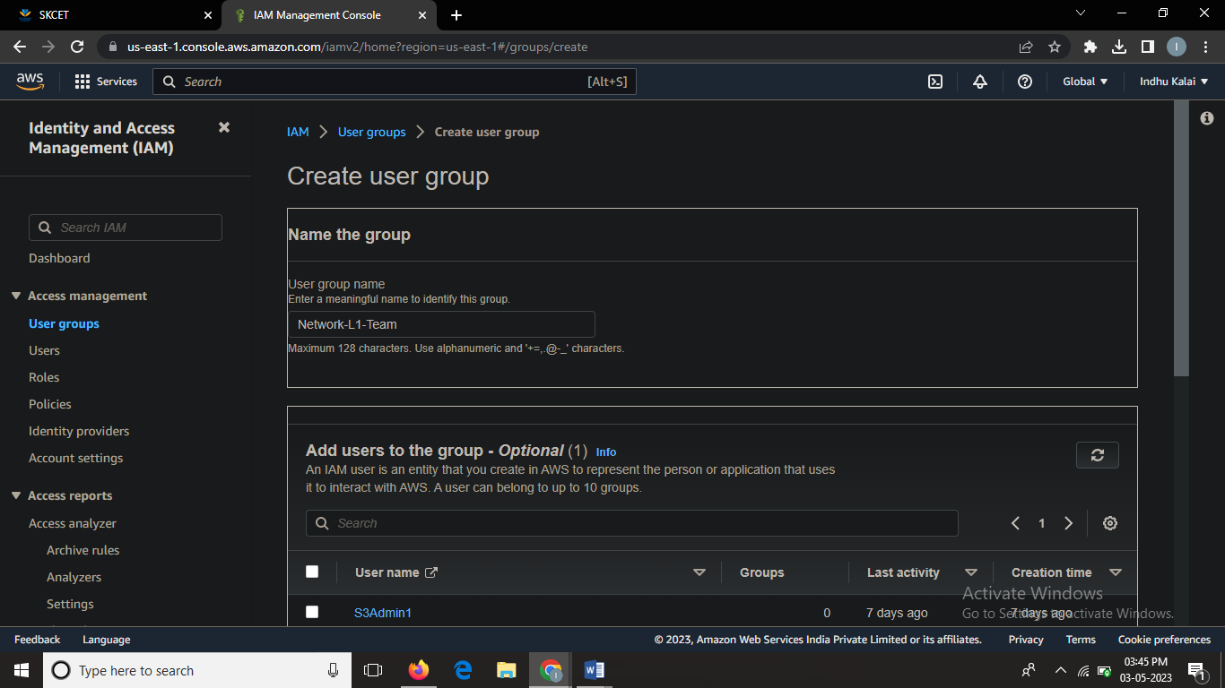

Creating group with the policies named “AmazonVPCReadOnlyAccess” and “AmazonNetworkManagerReadOnlyAccess”

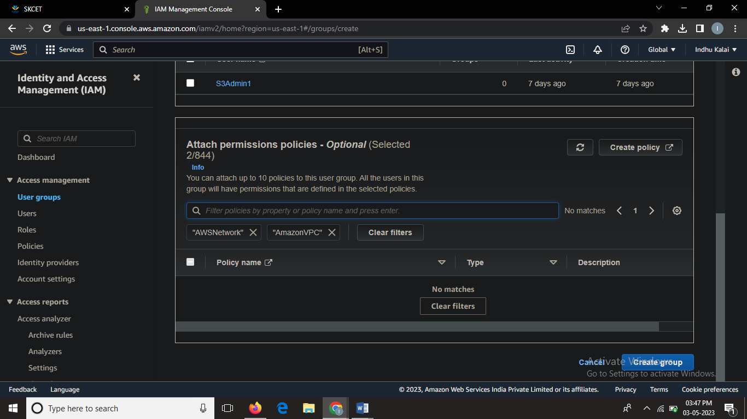

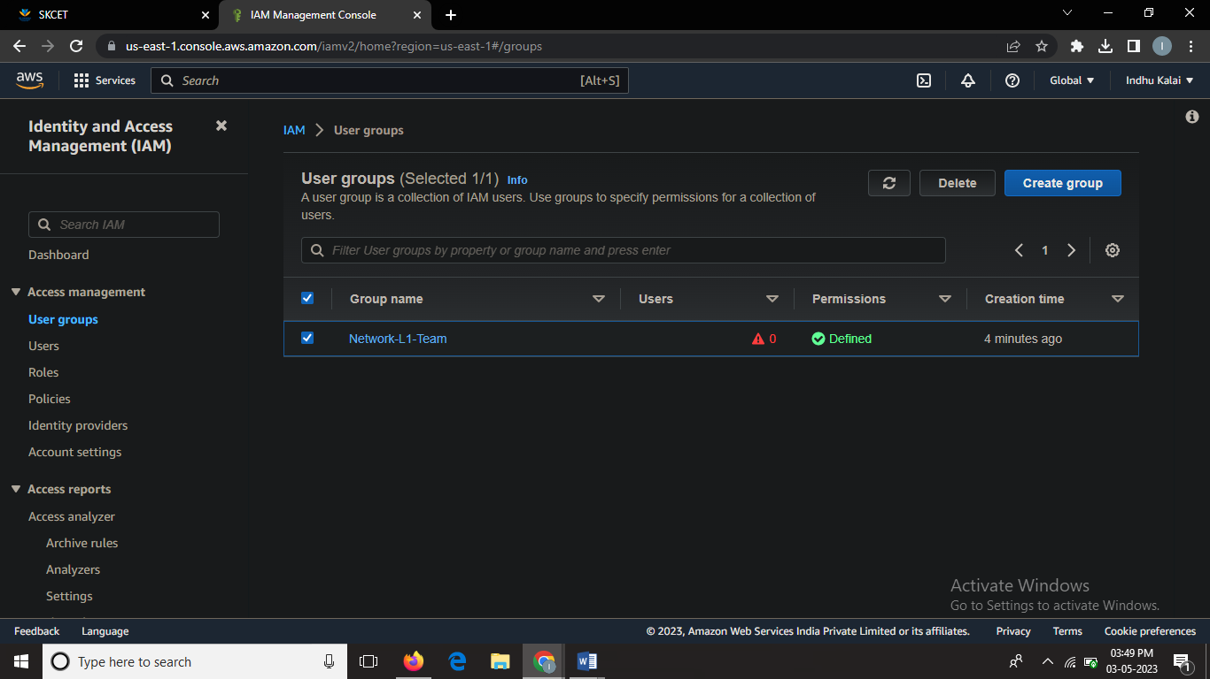

Thus the user group has been successfully created

Step2:



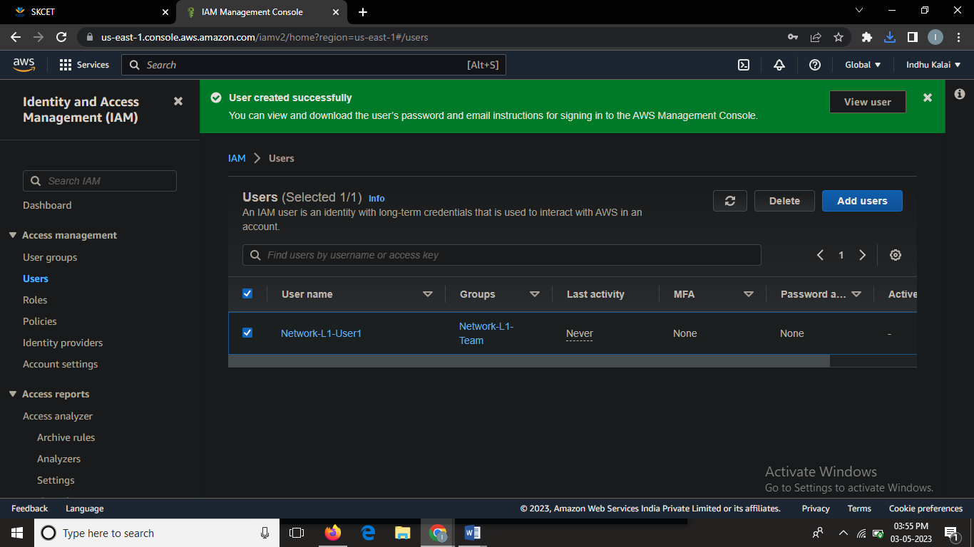

Step3:

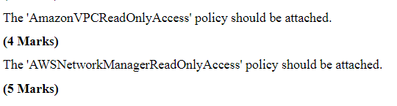

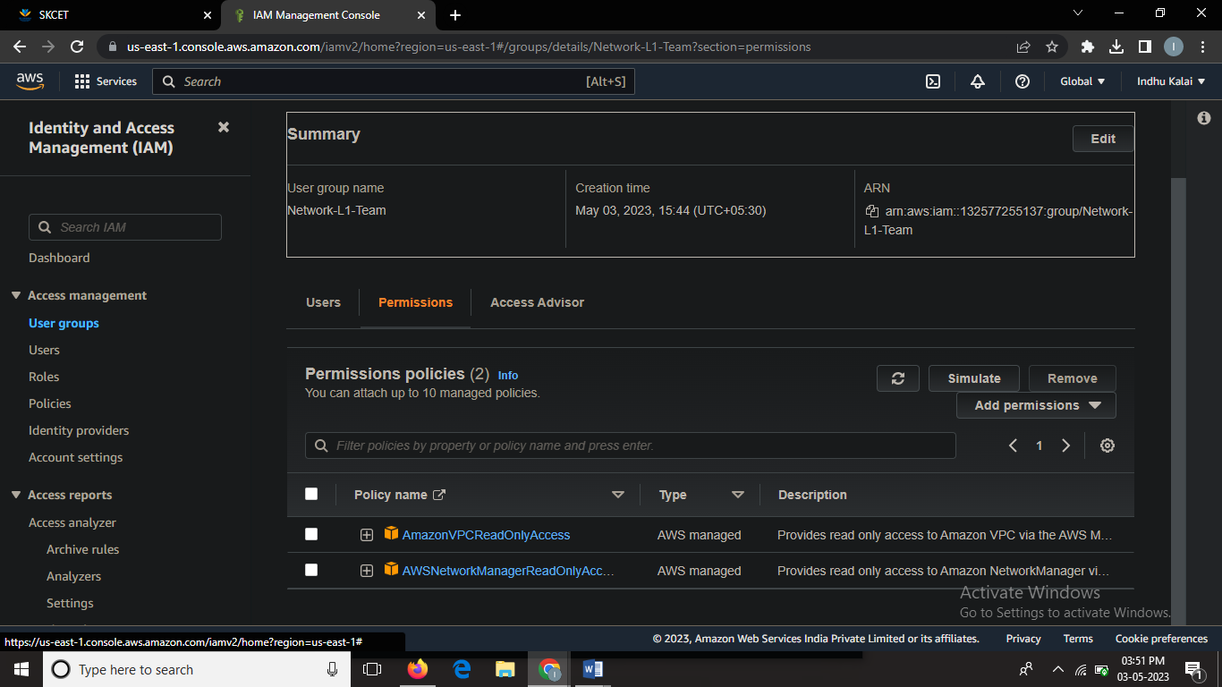

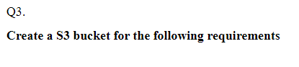

OUTPUT(SCREENSHOTS)



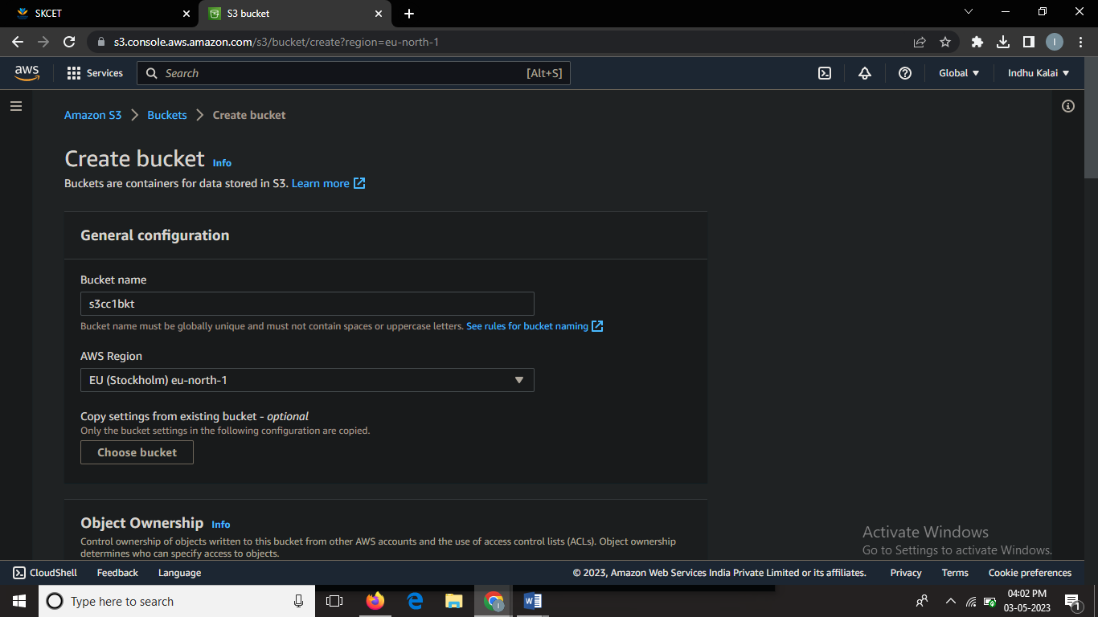

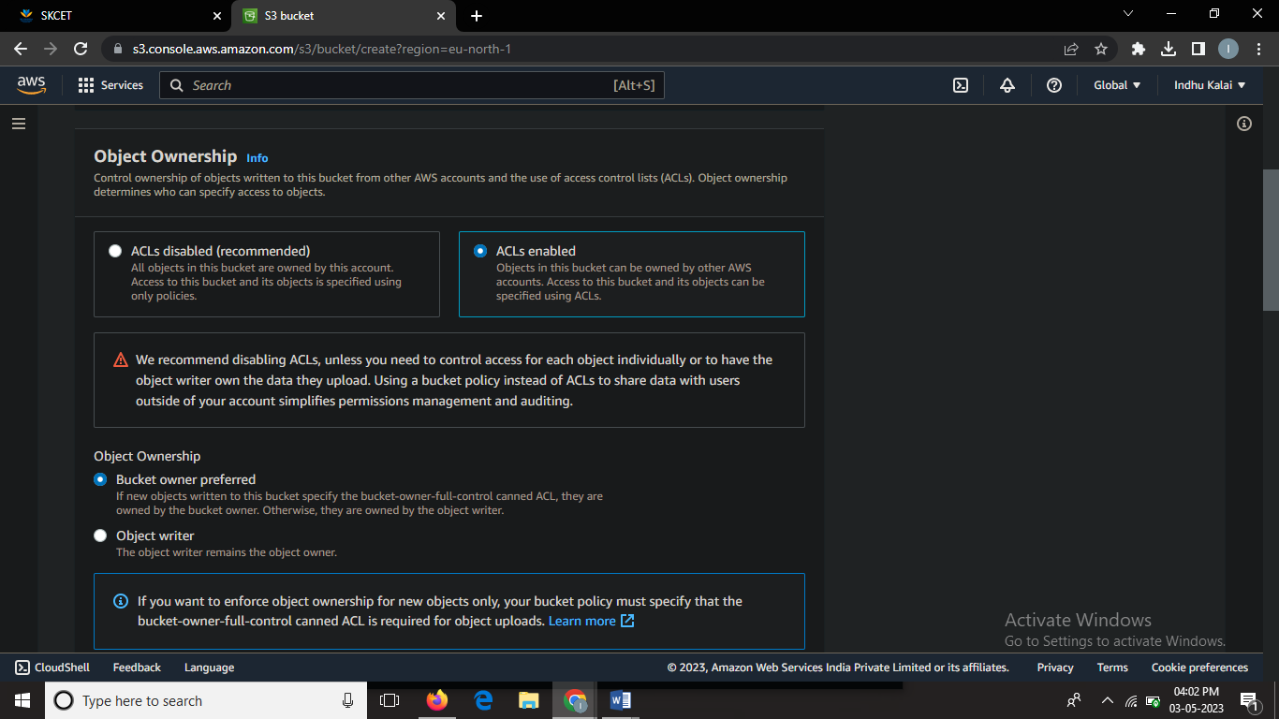



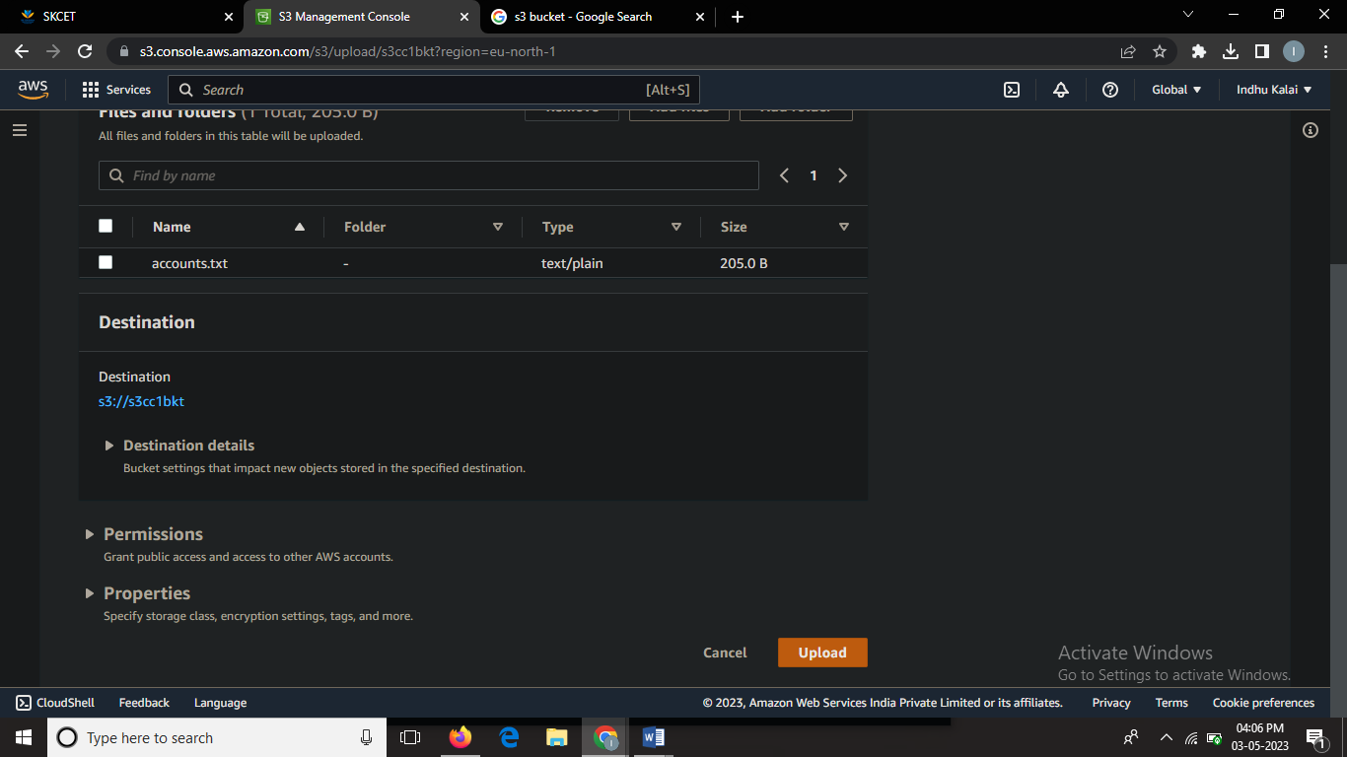

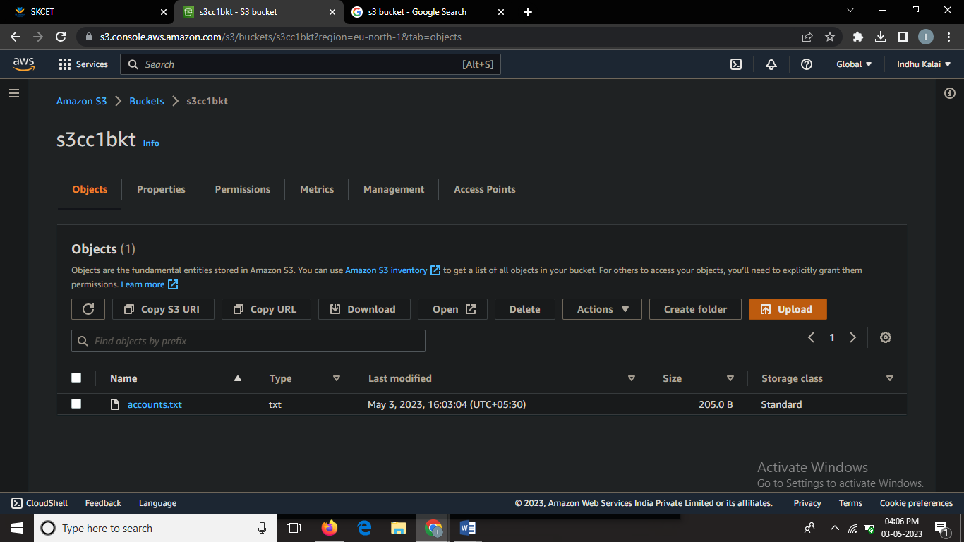

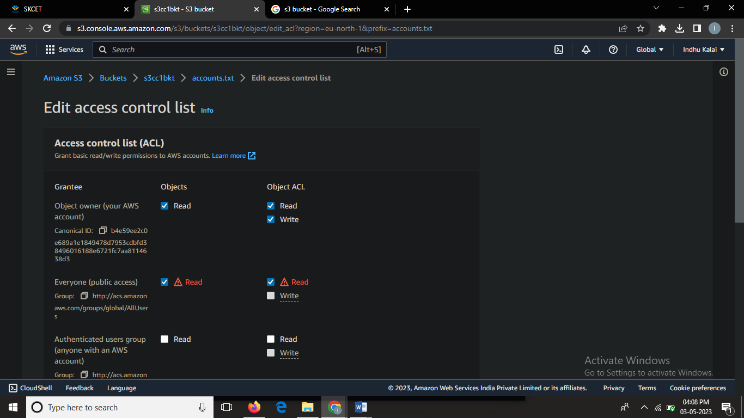

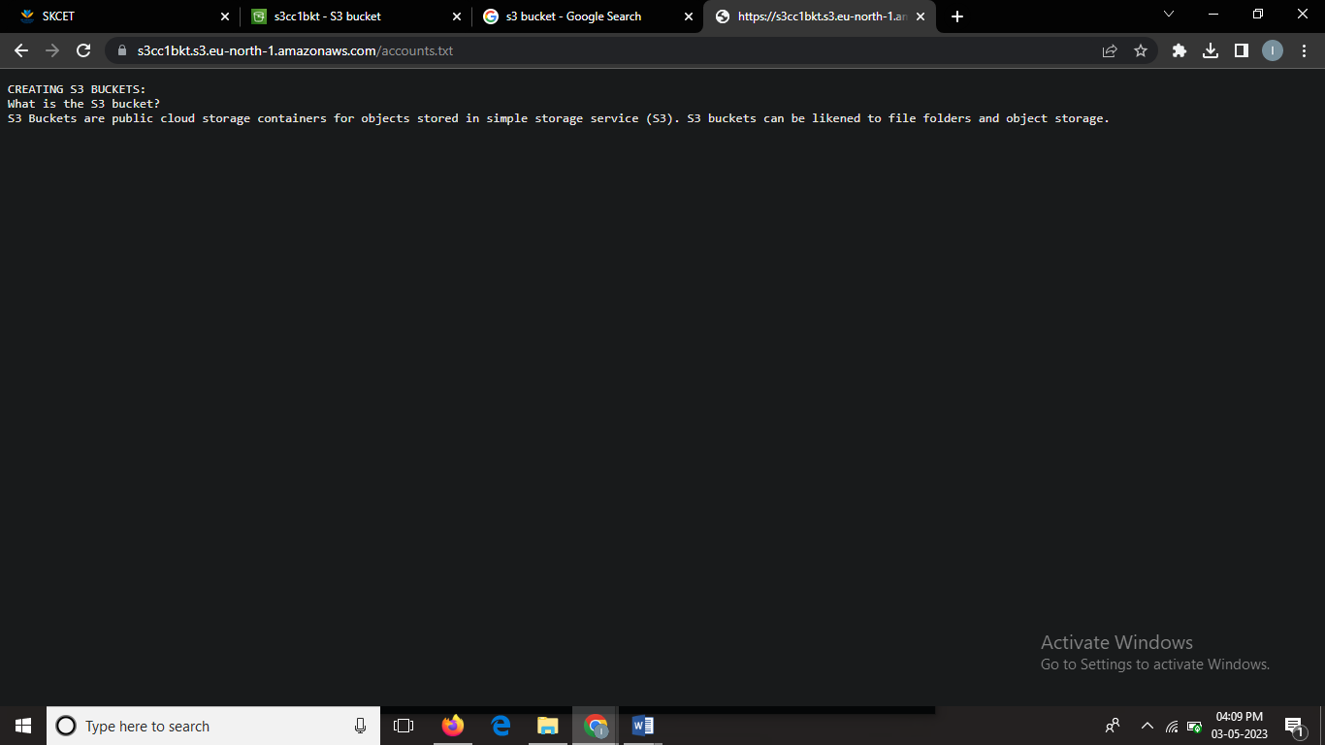

Thus the object is accessible to publically